horizontal line

**Delhi Technological University**

Department of Applied Physics

IVth Semester

**MICROPROCESSORS & INTERFACING**

**MPI EP - 206**

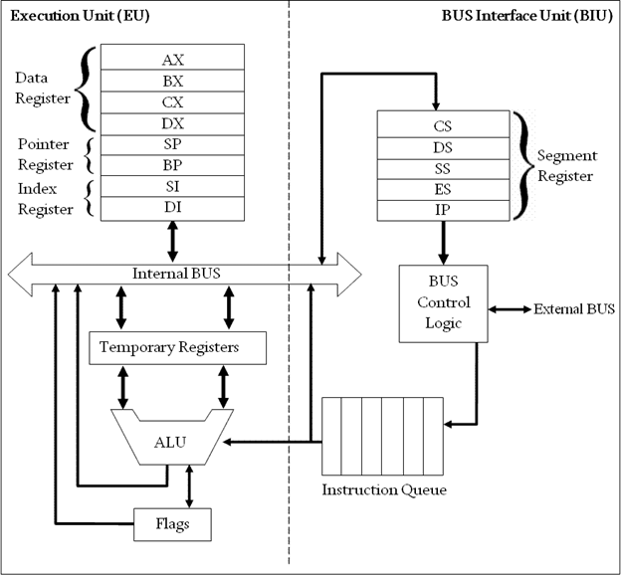

# **Submitted by :**

**ADITYA SINGH, 2K19/EP/005**

**Submitted to:**

**Dr. Rishu Chaujar**

# **Experiment 3**

**Division of two 8-bit Numbers**

**THEORY**

1. Include the emu8086.inc library and start the data and code segments.
2. Input the first number into the AL register using the int 21h interrupt.
3. Subtract 48 (ASCII value of 0) form the AL register to convert the number into decimal from ASCII.
4. Store this number into the BL register.
5. Print a newline and return carriage to the new line .
6. Input the second number into AL register and repeat step 3.
7. Clear the AH register by using the code : mov ah,00h
8. Divide the two numbers using the code :

div bl

which performs(ax)/(bl) and stores the quotient in AL register and remainder in AH register.

1. Copy the contents of the AX register into the BX register.
2. Add 48 to the BH and BL registers to convert it back to ASCII.
3. Repeat step 5 and print the quotient and remainder to the output screen .

**CODE**

**include 'emu8086.inc'**

**.data**

**.code**

**main proc**

**print "Enter first number: "**

**mov ah,01h**

**int 21h**

**sub al,48**

**mov bl,al**

**mov dl,10**

**mov ah,02h**

**int 21h**

**mov dl,13**

**mov ah,02h**

**int 21h**

**print "Enter second number: "**

**mov ah,01h**

**int 21h**

**sub al,48**

**mov ah,00h**

**div bl**

**mov bl,al**

**add bl,48**

**mov bh,ah**

**add bh,48**

**mov dl,10**

**mov ah,02h**

**int 21h**

**mov dl,13**

**mov ah,02h**

**int 21h**

**print "Quotient: "**

**mov dl,bl**

**mov ah,02h**

**int 21h**

**mov dl,10**

**mov ah,02h**

**int 21h**

**mov dl,13**

**mov ah,02h**

**int 21h**

**print "Remainder: "**

**mov dl,bh**

**mov ah,02h**

**int 21h**

**main endp**

**end main**

**OUTPUT**

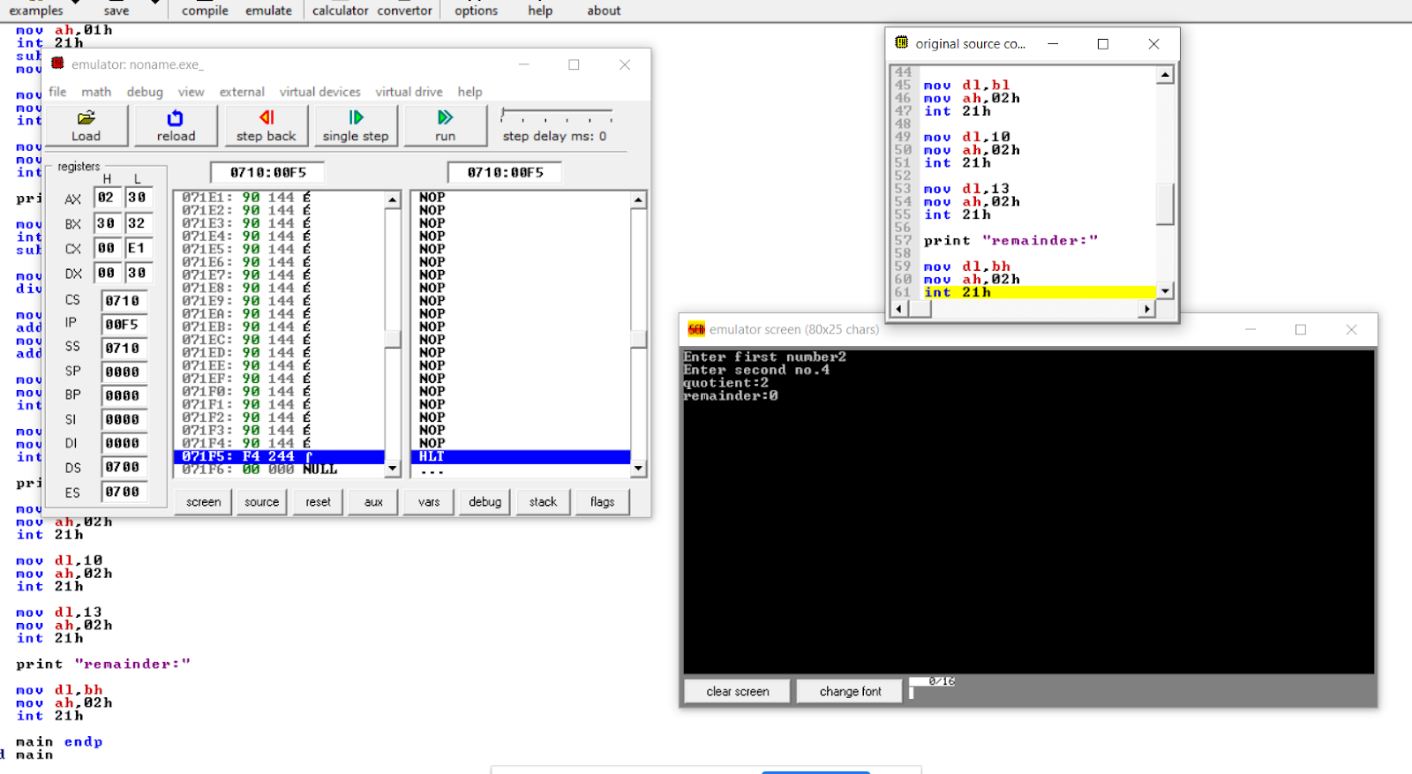

**END**